# UNAKOTI , TRIPURA (art form)

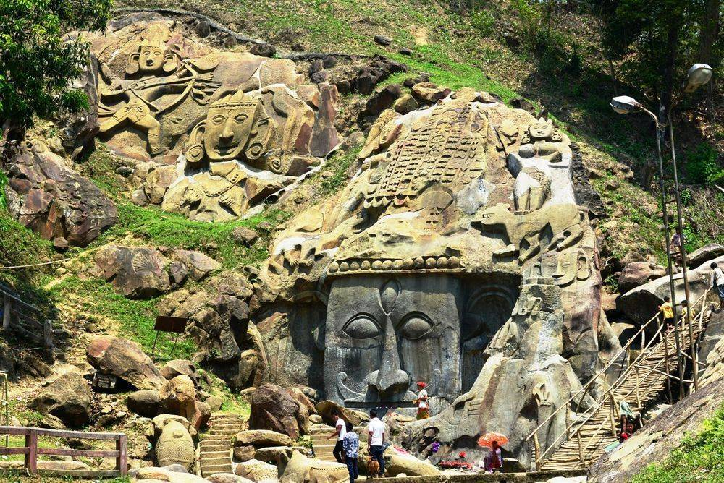

<https://magicpin.in/blog/20-unexplored-historical-places-india/>

Rock carvings, murals, and natural waterfalls are what best defines this place and what makes this place historical is the Shaiba pilgrimage dating back to 7th and 9th centuries. The legendary fact is that this is the place where Lord Shiva rested on his way to Kashi. When all the other gods and goddesses could not wake up in time Lord Buddha set out on his path by himself cursing the others to be turned to stones. This is why we see one less than one crore stone images and carvings in Unakoti. The Unakotiswara Kal Bhairava is Shiva’s rock-cut carving that is about 30 feet high, surrounded by rock effigies of two females. The same was featured in the Tripura Tableau at the 2016 Republic Day Parade.

<https://magicpin.in/blog/20-unexplored-historical-places-india/>

The kokborok name of **Unakoti** is **Subrai Khung** as claimed by [Jamatia Hoda](https://en.wikipedia.org/wiki/Jamatia_Hoda); **Unakoti** hill literally means *one less a*[*koti*](https://en.wikipedia.org/wiki/Crore) in [Bengali](https://en.wikipedia.org/wiki/Bengali_language), hosts an ancient [Shaivite](https://en.wikipedia.org/wiki/Shaiva) place of worship with huge [rock reliefs](https://en.wikipedia.org/wiki/Rock_relief) celebrating [Shiva](https://en.wikipedia.org/wiki/Shiva). It is the prime tourist spot of [Unakoti District, Tripura](https://en.wikipedia.org/wiki/Unakoti_district) in the [Kailashahar](https://en.wikipedia.org/wiki/Kailashahar) Subdivision in the [North-eastern](https://en.wikipedia.org/wiki/North_East_India) [Indian](https://en.wikipedia.org/wiki/India) [state](https://en.wikipedia.org/wiki/States_and_territories_of_India) of [Tripura](https://en.wikipedia.org/wiki/Tripura).[[1]](https://en.wikipedia.org/wiki/Unakoti#cite_note-1) It is Shiva pilgrimage and dates back to 7th – 9th centuries if not earlier. In those time the Pala dynasty ruled over the Bengal. Tripura region was a part of Greater Bengal under Samatat. Historians said (Nihar Ranjan Ray, Rakhaldas Bondopadhaya) the kingdom of Tripura was also a center of East Bengal and Samatat. The Tripura kingdom started to rule over the region in the 14-th century.

The images found at Unakoti are of two types: namely rock-carved figures and stone images. Among the rock-cut carvings, the central Shiva head and gigantic [Ganesha](https://en.wikipedia.org/wiki/Ganesha) figures deserve special mention. The central Shiva head known as **Unakotiswara Kal Bhairava** is about 30 feet high including an embroidered head-dress which itself is 10 feet high. On each side of the head-dress of the central Shiva, there are two full-size female figures - one of [Durga](https://en.wikipedia.org/wiki/Durga) standing on a lion and another female figure on the other side. In addition, three enormous images of [Nandi Bull](https://en.wikipedia.org/wiki/Nandi_(bull)) are found half-buried in the ground. There are various other stone as well as rock-cut images at Unakoti.

## Festival[[edit](https://en.wikipedia.org/w/index.php?title=Unakoti&action=edit&section=2)]

Every year a big fair popularly known as **Ashokastami Mela** is held in the month of April. The festival is visited by thousands of pilgrims. Another smaller festival takes place in January.

Upto here = <https://en.wikipedia.org/wiki/Unakoti>

Tucked away in the forests of Tripura, Unakoti is basically a pilgrimage site dedicated to Lord Shiva, and is believed to be 11-13 centuries old.  
While, in Tripura, infrastructural developments might be hardly trickling in, it is distinguished for a paradise-like region on the Jampui Hills of North Tripura. Situated around 178 kilometres from Agartala, the heritage site ‘Lost Hill Faces’ of Unakoti, is home to giant bas-relief sculptures carved out of a huge hill. The huge sculptures carry a tribal look and exude almost the same mystical charm as the spell-binding figures in the [Angkor Wat](https://timesofindia.indiatimes.com/travel/siem-reab/angkor-wat/ps45110409.cms) Temple of Cambodia.  
  
Unakoti, which means “less than a crore in number”, has several discovered and yet-to-be-discovered sculptures of Hindu gods and goddesses. Of all, the 30-ft-long carving of Lord Shiva’s head called Unakotishwara Kal Bhairav is the most revered of all.

Upto here - <https://timesofindia.indiatimes.com/travel/destinations/mystical-sculptures-of-hindu-deities-lay-unexplored-in-tripuras-unakoti-hill/as62833216.cms>

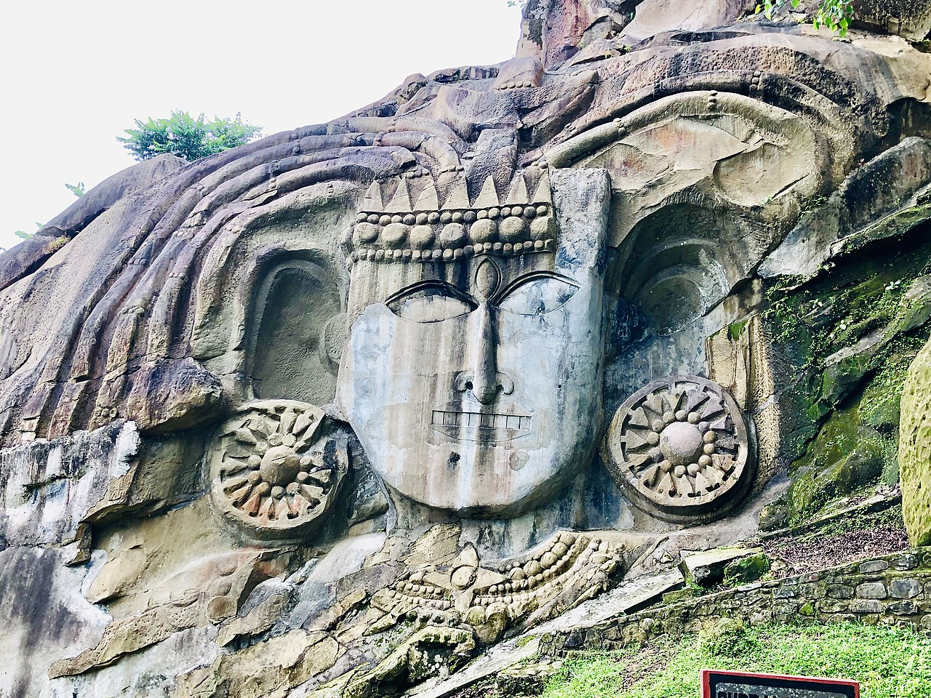

Src - <https://upload.wikimedia.org/wikipedia/commons/thumb/e/ee/Unakoti_1.jpg/1280px-Unakoti_1.jpg>

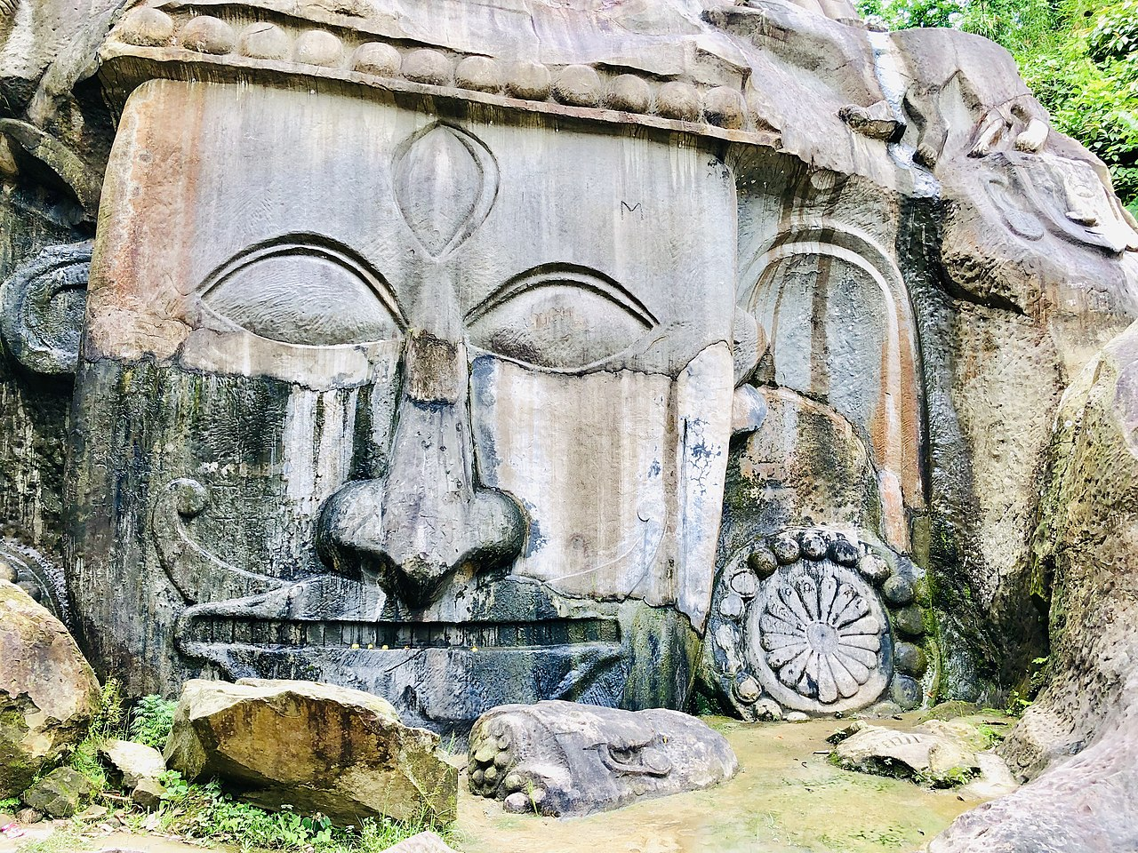

Src - <https://upload.wikimedia.org/wikipedia/commons/thumb/2/23/Unakoti_5.jpg/1280px-Unakoti_5.jpg>

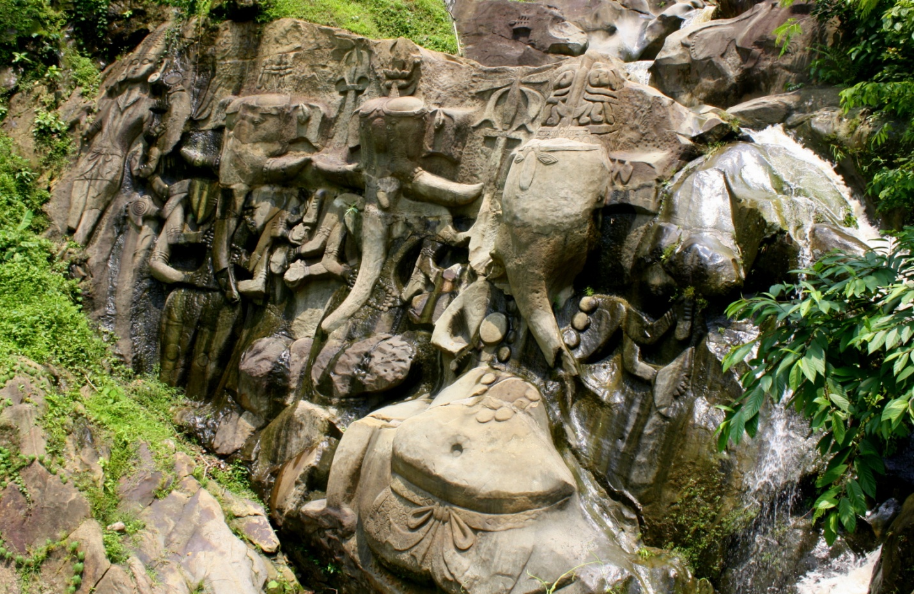

Src = <https://upload.wikimedia.org/wikipedia/commons/8/8f/Ganesha%2C_Unakoti_%28_%E0%A6%8A%E0%A6%A8%E0%A6%95%E0%A7%8B%E0%A6%9F%E0%A6%BF%29.JPG>

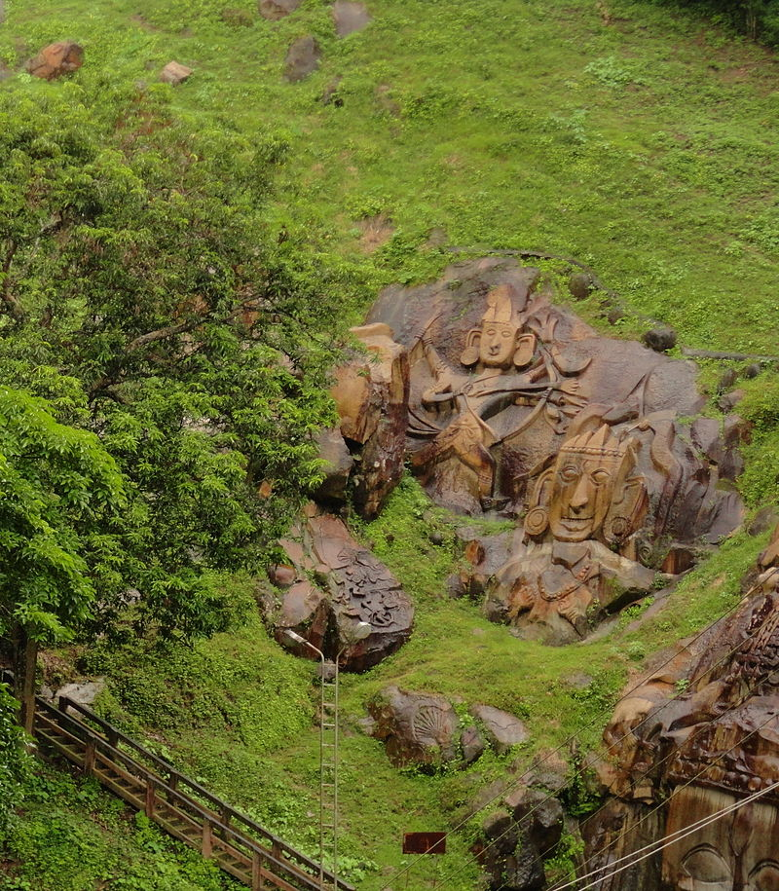

Src = <https://upload.wikimedia.org/wikipedia/commons/thumb/b/bf/Unakoti_%28Scorpian_ad%29.JPG/800px-Unakoti_%28Scorpian_ad%29.JPG>

# PATTACHITRA =

**Pattachitra** or **Patachitra** is a general term for traditional, cloth-based [scroll](https://en.wikipedia.org/wiki/Scroll) painting,[[5]](https://en.wikipedia.org/wiki/Pattachitra#cite_note-5) based in the eastern Indian [states](https://en.wikipedia.org/wiki/States_and_territories_of_India) of [Odisha](https://en.wikipedia.org/wiki/Odisha)[[6]](https://en.wikipedia.org/wiki/Pattachitra#cite_note-6)[[7]](https://en.wikipedia.org/wiki/Pattachitra#cite_note-7) and [West Bengal](https://en.wikipedia.org/wiki/West_Bengal).[[8]](https://en.wikipedia.org/wiki/Pattachitra#cite_note-8) Pattachitra artform is known for its intricate details as well as mythological narratives and folktales inscribed in it. Pattachitra is one of the ancient artworks of [Odisha](https://en.wikipedia.org/wiki/Odisha), originally created for ritual use and as souvenirs for pilgrims to Puri, as well as other temples in Odisha.[[9]](https://en.wikipedia.org/wiki/Pattachitra#cite_note-9) Pattachitras are a component of an ancient [Bengali](https://en.wikipedia.org/wiki/Bengalis) narrative art, originally serving as a visual device during the performance of a song.[[10]](https://en.wikipedia.org/wiki/Pattachitra#cite_note-chitrolekha.com-10)

## Significance of the name[[edit](https://en.wikipedia.org/w/index.php?title=Pattachitra&action=edit&section=1)]

In the [Sanskrit language](https://en.wikipedia.org/wiki/Sanskrit_language), "Patta" literally means "cloth" and "Chitra" means "picture". Most of these paintings depict stories of Hindu deities.[[11]](https://en.wikipedia.org/wiki/Pattachitra#cite_note-11)

### Theme and Style[[edit](https://en.wikipedia.org/w/index.php?title=Pattachitra&action=edit&section=4)]

The theme of Odia painting centres round the [Jagannath](https://en.wikipedia.org/wiki/Jagannath) and the [Vaishnava](https://en.wikipedia.org/wiki/Vaishnava) sect. Since beginning of Pattachitra culture, Lord [Jagannath](https://en.wikipedia.org/wiki/Jagannath) who was an incarnation of Lord [Krishna](https://en.wikipedia.org/wiki/Krishna) has been the major source of inspiration. The subject matter of Patta Chitra is mostly mythological, religious stories and [folk lore](https://en.wikipedia.org/wiki/Folk_lore). Themes are chiefly on Lord Jagannath and [Radha](https://en.wikipedia.org/wiki/Radha)-[Krishna](https://en.wikipedia.org/wiki/Krishna), different "Vesas" of Shri Jagannath, [Balabhadra](https://en.wikipedia.org/wiki/Balabhadra) and [Subhadra](https://en.wikipedia.org/wiki/Subhadra), temple activities, the ten incarnations of [Vishnu](https://en.wikipedia.org/wiki/Vishnu) basing on the '[Gita Govinda](https://en.wikipedia.org/wiki/Gita_Govinda)' of [Jayadev](https://en.wikipedia.org/wiki/Jayadeva), Kama Kujara [Navagunjara](https://en.wikipedia.org/wiki/Navagunjara), [Ramayana](https://en.wikipedia.org/wiki/Ramayana), [Mahabharata](https://en.wikipedia.org/wiki/Mahabharata).[[18]](https://en.wikipedia.org/wiki/Pattachitra#cite_note-18) The individual paintings of gods and goddesses are also being painted.

The Pattachitra style are mix of both folk and classical elements but leanings more towards folk forms. The dress style has [Mughal](https://en.wikipedia.org/wiki/Mughal_Empire) influences. All of the poses have been confined to a few well-defined postures. These are not free from monotonous repetitions, though at times this is necessary to accentuate the narrative character of the style. The lines are bold and clean and angular and sharp. Generally, there are no landscapes, perspectives, and distant views. All the incidents are seen in close juxtaposition. The background on which the figures are represented, is delineated with decorations of flowers and foliages and is mostly painted in red colour. All the paintings are given decorative borders. The whole painting is conceived in the form of a design on a given canvas.

The themes may be classified into following categories[[19]](https://en.wikipedia.org/wiki/Pattachitra#cite_note-19)

* Jagannath paintings
* Vaishnav Paintings

a)Bhagabat paintings b)Ramayana paintings

* Saiva paintings
* Shakta paintings
* Paintings as legends
* Ragachitras
* Bandhachitra
* Yamapati and yatripatas – (sketches of puri temple) [Ganjapa](https://en.wikipedia.org/wiki/Ganjapa) playing card paintings and other socials themes on paintings.
* Navagunjara[[20]](https://en.wikipedia.org/wiki/Pattachitra#cite_note-20)
* Traditionally the painters are known as *chitrakars*. A patta painter's home with all the members of family is his studio. Woman members prepare the glue, the canvas and apply colours what we call the fill-in, and give the final lacquer coating. The master hand, mostly the male member, draws the initial line and gives the final finishing. Patta paintings are done on small strips of [cotton](https://en.wikipedia.org/wiki/Cotton) cloth. The [canvas](https://en.wikipedia.org/wiki/Canvas) is prepared by coating the clothing with a mixture of chalk and gum made from [tamarind](https://en.wikipedia.org/wiki/Tamarind) seeds. Then it is rubbed by taking the help of two different stones and then the cloth is dried. The mixture of gum and [chalk](https://en.wikipedia.org/wiki/Chalk) gives the cloth's surface a leathery finish on which the artists paint with vegetable, earth and stone colours.[[21]](https://en.wikipedia.org/wiki/Pattachitra#cite_note-21)
* The painters do not use pencil or [charcoal](https://en.wikipedia.org/wiki/Charcoal) for the preliminary drawings. They are so expert in the line that they simply draw directly with the brush either in light red or yellow. Then the colours are filled in. The final lines are drawn and the patta is given a lacquer coating to protect it from weather, thus making the painting glossy. This process of glazing or [varnishing](https://en.wikipedia.org/wiki/Varnishing) is quite interesting. The painting is held over a fireplace so that the back of the painting is exposed to heat. On the surface of the painting fine lacquer is applied.[[*citation needed*](https://en.wikipedia.org/wiki/Wikipedia:Citation_needed)]

### Colour[[edit](https://en.wikipedia.org/w/index.php?title=Pattachitra&action=edit&section=6)]

* In the 16th century, with the emergence of [Bhakti movement](https://en.wikipedia.org/wiki/Bhakti_movement) the paintings of Radha and Krishna were painted in vibrant shades of orange, red and yellow. There are typical scenes and figures like Krishna, Gopis, elephants, trees and other creatures are seen in these paintings. Krishna is always painted in blue and Gopis in light pink, purple or brown colours.[[22]](https://en.wikipedia.org/wiki/Pattachitra#cite_note-22)
* The painters use vegetable and mineral colours without going for factory-made poster colours. They prepare their own colours.[[23]](https://en.wikipedia.org/wiki/Pattachitra#cite_note-23) White colour is made from the [conch](https://en.wikipedia.org/wiki/Conch)-shells by powdering, [boiling](https://en.wikipedia.org/wiki/Boiling) and [filtering](https://en.wikipedia.org/wiki/Filter_(chemistry)) in a very hazardous process. It requires a lot of patience. But this process gives brilliance and premanence to the [hue](https://en.wikipedia.org/wiki/Hue). 'Hingula', a mineral colour, is used for red. 'Haritala', king of stone ingredients for yellow, 'Ramaraja' a sort of indigo for blue are being used. Pure [lamp](https://en.wikipedia.org/wiki/Oil_lamp)-[black](https://en.wikipedia.org/wiki/Black) or black prepared from the burning of [coconut](https://en.wikipedia.org/wiki/Coconut) shells are used.[[24]](https://en.wikipedia.org/wiki/Pattachitra#cite_note-24) There was no blue either cobalt or ultramarine in the earlier colour schemes. The colours used in the Patta paintings are primarily bright colours, limited to red, yellow, indigo, black and white. The brushes that are used by these 'Chitrakaras' are also indigenous and are made of hair of domestic animals. A bunch of hair tied to the end of a [bamboo](https://en.wikipedia.org/wiki/Bamboo) stick make the brush.[[25]](https://en.wikipedia.org/wiki/Pattachitra#cite_note-25)
* Upto here = <https://en.wikipedia.org/wiki/Pattachitra>

## ****PATTACHITRA**** - OLDEST AND MOST POPULAR ART FORMS OF ODISHA.

Pattachitra artform is known for its intricate details as well as mythological narratives and folktales inscribed in it. Some of the popular themes represented through this art form are Thia Badhia - depiction of the temple of Jagannath; Krishna Lila - enactment of Jagannath as Lord Krishna displaying his powers as a child; Panchamukhi - depiction of Lord Ganesh as a five-headed deity.

This old tradition of Odia painting still survives in the places like Puri, Raghurajpur, Paralakhemundi, Chikiti and Sonepur.

## ****ORIGIN****

The paintings of Orissa can be divided into three categories from the point of view of medium, i.e. paintings on cloth or 'Patta Chitra', paintings on walls or 'Bhitti Chitra' and palm leaf engravings or "Tala Patra Chitra' or "Pothi, Chitra'. The style of all these remains more or less the same at a specific time because the then artists were commissioned to work in all these media, it is believed.

The painting the 'pattachitra' resemble the old murals of Odisha especially religious centres of Puri, Konark and Bhubaneshwar region, dating back to the 5th century BC. The best work is found in and around Puri, especially in the village of Raghurajpur.[12]

## ****HISTORY****

The oldest record of Patta Paintings does not probably go beyond the establishment of the present shrine of Shri Jagannath at Puri. It may be due to the fact that paintings do not survive like sculptures. The paints inside the shrines of Lord Jagannath at Puri make the date probable. The oldest classical marble paintings of Sitabanji at Keonjhar do not conform to the present style of Patta painting wholly. The wooden statues of the three deities are also covered with cloth and then overlaid with glue mixed with chalk, and then given paint only with four limited colours of red, yellow, white and black. The deities who are held in high esteem by the Odias and who inspire religion, life and activity of the people also carry with them a tradition of art and painting which is as old as the deities themselves. If the Savara origin of Jagannath is accepted, the date of the Patta paintings can be dated back to an earlier period.

* Upto here = <https://www.sid.edu.in/shilpkatha/UEDProjects/bhavya/about.html>

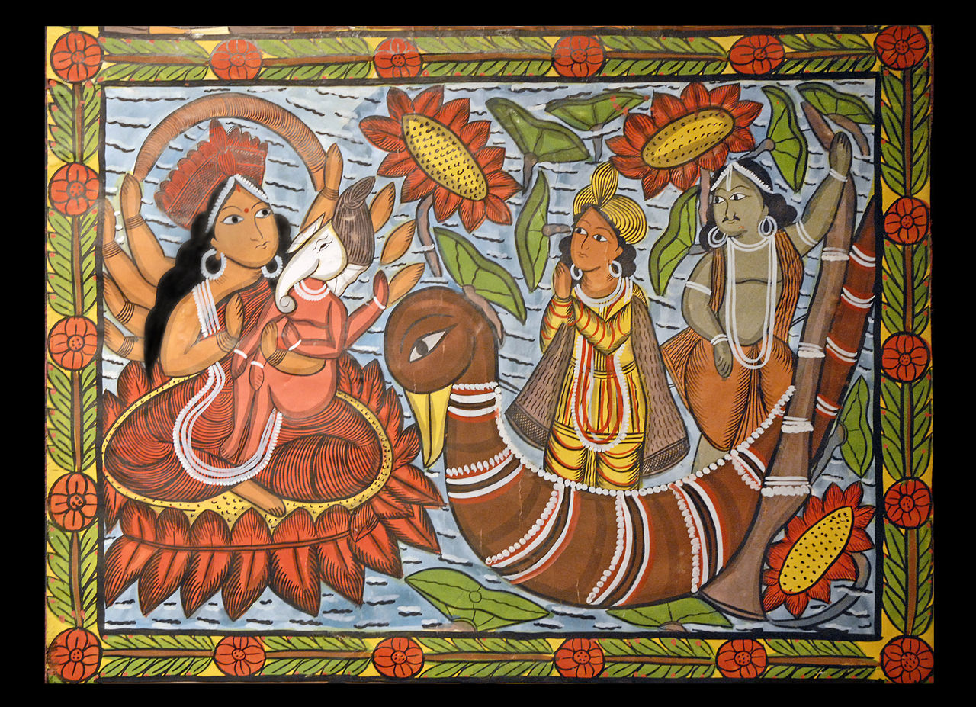

SRC - <https://upload.wikimedia.org/wikipedia/commons/thumb/1/15/Extrait_de_Chandi_Mangal_de_Meena_Chitrakar_%28Naya_Bengale%29_%281439706046%29.jpg/1280px-Extrait_de_Chandi_Mangal_de_Meena_Chitrakar_%28Naya_Bengale%29_%281439706046%29.jpg>

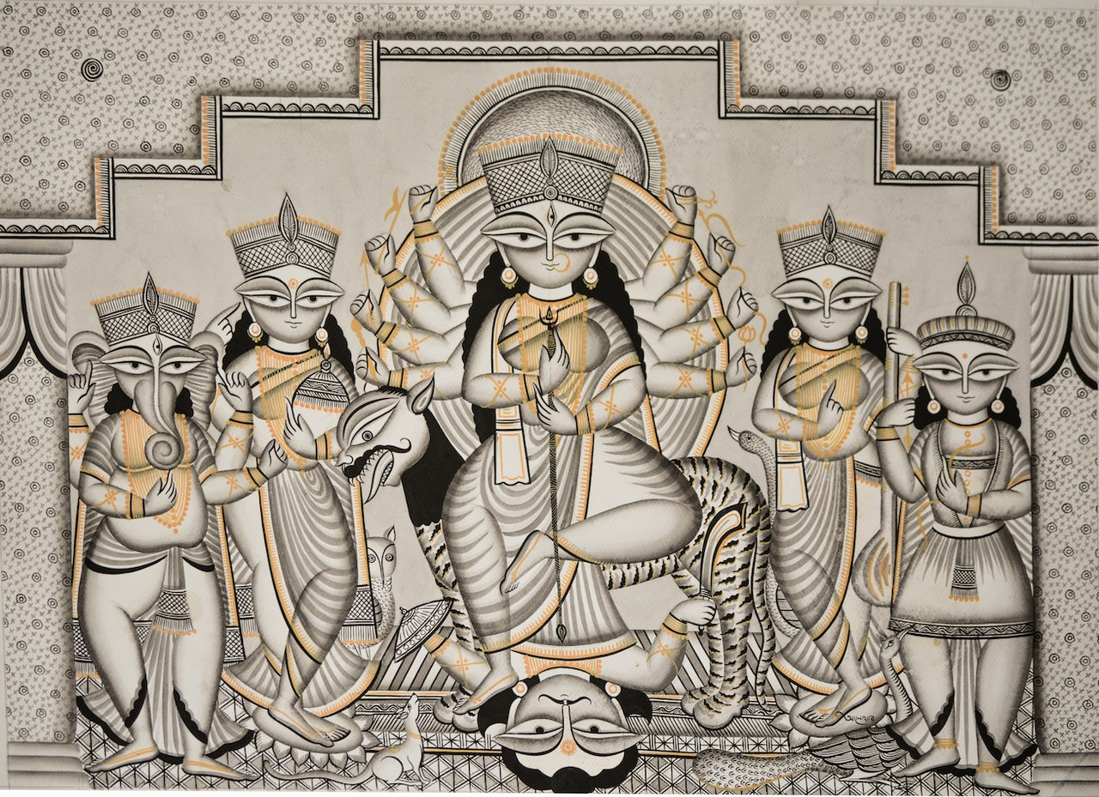

SRC = <https://upload.wikimedia.org/wikipedia/commons/thumb/1/1c/Medinipur_Patachitra_-_durga.jpg/1280px-Medinipur_Patachitra_-_durga.jpg>

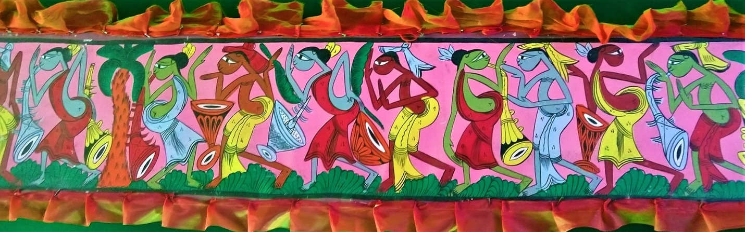

SRC - <https://upload.wikimedia.org/wikipedia/commons/thumb/8/81/Bengal_Patachitra_1.jpg/1920px-Bengal_Patachitra_1.jpg>

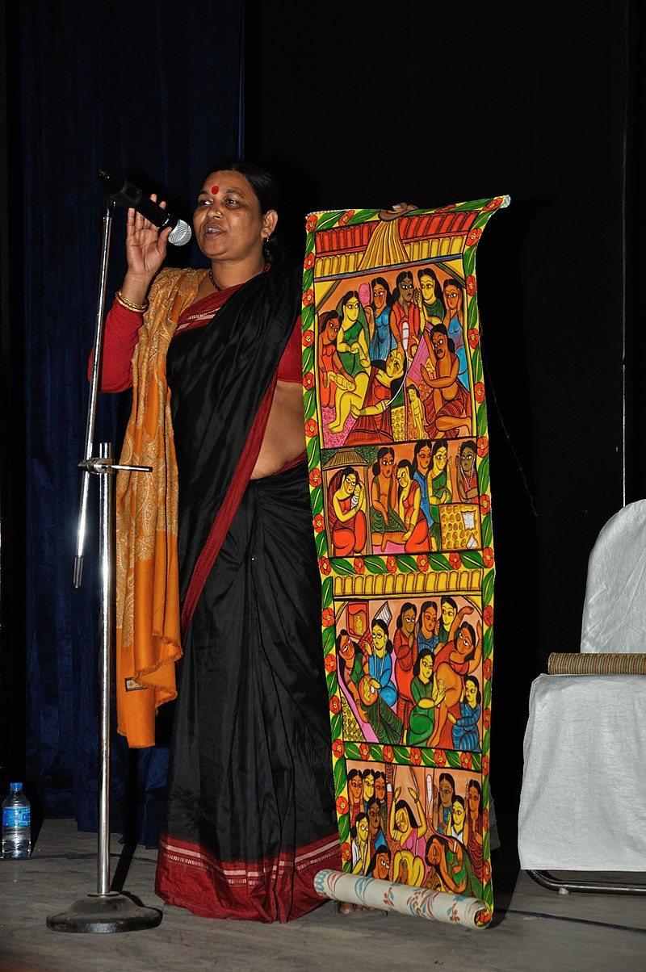

SRC - <https://upload.wikimedia.org/wikipedia/commons/thumb/6/6c/Swarna_Chitrakar_-_Kolkata_2014-02-14_3080.JPG/800px-Swarna_Chitrakar_-_Kolkata_2014-02-14_3080.JPG>

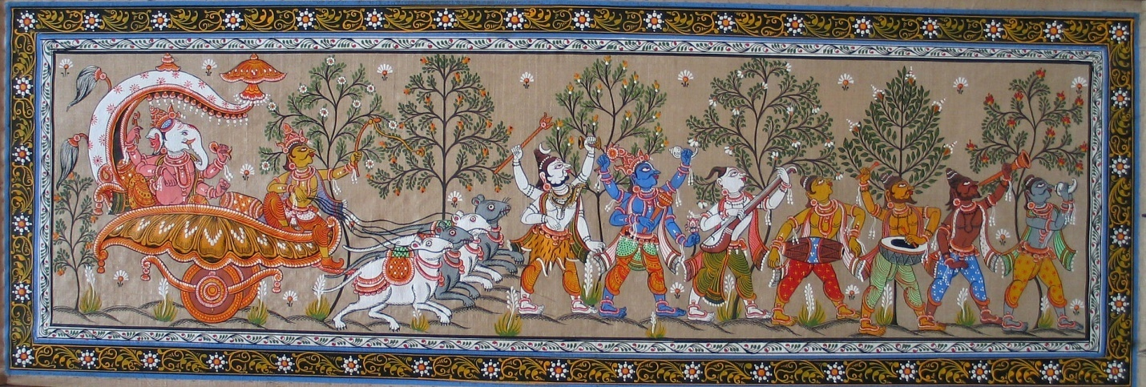

Src = <https://upload.wikimedia.org/wikipedia/commons/thumb/6/6e/Patta_Chitra_02.jpg/1920px-Patta_Chitra_02.jpg>

# MITHILA PAINTINGS =

The Mithila painting is one of the living creative activities of the women of Bihar. It is a form of folk painting on paper, cloth, readymade garments, movable objects that is mainly done by the village women of Mithila. Originally it was a folk art, practiced by women of all castes and communities using natural and vegetable colours. Since it’s practised in only one village, and very few women make these paintings, we know that it’s one of the dying traditions of India.

UPTO HERE = <https://www.indiatimes.com/culture/who-we-are/9-indian-art-forms-that-could-disappear-forever-if-they-re-not-saved-250533.html>

**Madhubani art** (or **Mithila painting**) is a style of Nepali and [Indian painting](https://en.wikipedia.org/wiki/Indian_painting), practiced in the [Mithila region](https://en.wikipedia.org/wiki/Mithila_(region)) of the [Indian subcontinent](https://en.wikipedia.org/wiki/Indian_subcontinent). This painting is done with a variety of tools, including fingers, twigs, brushes, nib-pens, and matchsticks and using natural dyes and pigments. It is characterised by its eye-catching geometrical patterns.[[*citation needed*](https://en.wikipedia.org/wiki/Wikipedia:Citation_needed)] There is ritual content for particular occasions, such as birth or marriage, and festivals, such as [Holi](https://en.wikipedia.org/wiki/Holi), Surya Shasti, [Kali Puja](https://en.wikipedia.org/wiki/Kali_puja), [Upanayana](https://en.wikipedia.org/wiki/Upanayana), and [Durga Puja](https://en.wikipedia.org/wiki/Durga_Puja).

## Origins[[edit](https://en.wikipedia.org/w/index.php?title=Madhubani_art&action=edit&section=1)]

Madhubani painting (Mithila painting) was traditionally created by the women of various communities in the Mithila region of the Indian subcontinent. It originated from [Madhubani district](https://en.wikipedia.org/wiki/Madhubani_district) of the [Mithila](https://en.wikipedia.org/wiki/Mithila_(region)) region of [Bihar](https://en.wikipedia.org/wiki/Bihar). Madhubani is also a major export center of these paintings.[[1]](https://en.wikipedia.org/wiki/Madhubani_art#cite_note-1) This painting as a form of wall art was practiced widely throughout the region; the more recent development of painting on paper and canvas mainly originated among the villages around Madhubani, and it is these latter developments that led to the term "Madhubani art" being used alongside "Mithila Painting."[[2]](https://en.wikipedia.org/wiki/Madhubani_art#cite_note-2)

The paintings were traditionally done on freshly plastered mud walls and floors of huts, but now they are also done on cloth, handmade paper and [canvas](https://en.wikipedia.org/wiki/Canvas).[[3]](https://en.wikipedia.org/wiki/Madhubani_art#cite_note-krupa-3) Madhubani paintings are made from the paste of powdered rice. Madhubani painting has remained confined to a compact geographical area and the skills have been passed on through centuries, the content and the style have largely remained the same. Thus, Madhubani painting has received GI ([Geographical Indication](https://en.wikipedia.org/wiki/Geographical_Indication)) status. Madhubani paintings use two-dimensional imagery, and the colors used are derived from plants. [Ochre](https://en.wikipedia.org/wiki/Ochre), [Lampblack](https://en.wikipedia.org/wiki/Lampblack) and [Red](https://en.wikipedia.org/wiki/Red) are used for reddish-brown and black, respectively.[[*citation needed*](https://en.wikipedia.org/wiki/Wikipedia:Citation_needed)]

Madhubani paintings mostly depict people and their association with nature and scenes and deities from the ancient epics. Natural objects like the sun, the moon, and religious plants like [tulsi](https://en.wikipedia.org/wiki/Tulsi) are also widely painted, along with scenes from the royal court and social events like weddings. Generally, no space is left empty; the gaps are filled by paintings of flowers, animals, birds, and even geometric designs.[[*citation needed*](https://en.wikipedia.org/wiki/Wikipedia:Citation_needed)] Traditionally, painting was one of the skills that was passed down from generation to generation in the families of the Mithila Region, mainly by women.[[4]](https://en.wikipedia.org/wiki/Madhubani_art#cite_note-4) It is still practiced and kept alive in institutions spread across the Mithila region. [Kalakriti](https://en.wikipedia.org/w/index.php?title=Kalakriti&action=edit&redlink=1)[[5]](https://en.wikipedia.org/wiki/Madhubani_art#cite_note-5) in Darbhanga,[[6]](https://en.wikipedia.org/wiki/Madhubani_art#cite_note-6) Vaidehi in Madhubani, Benipatti in Madhubani district and Gram Vikas Parishad in Ranti are some of the major centres of Madhubani painting which have kept this ancient art form alive.[[*citation needed*](https://en.wikipedia.org/wiki/Wikipedia:Citation_needed)]

## Styles[[edit](https://en.wikipedia.org/w/index.php?title=Madhubani_art&action=edit&section=2)]

Madhubani art has five distinctive styles: Bharni, Kachini, Tantrik, Godna and Kohbar. In the 1960s Bharni, Kachni and Tantrik styles were mainly done by Brahman and Kayashth women, who are 'upper caste' women in India and Nepal. Their themes were mainly religious and they depicted Gods and Goddesses paintings. People of lower castes included aspects of their daily life and symbols, the story of Raja Shailesh [guard of the village] and much more, in their paintings. Nowadays Madhubani art has become a globalised art form, so there is no difference in the work on the basis of the caste system. They work in all five styles. Madhubani art has received worldwide attention.[[7]](https://en.wikipedia.org/wiki/Madhubani_art#cite_note-a-painter-from-patna-crafted-a-live-madhubani-painting-in-bangkok/-7)

## Contributions[[edit](https://en.wikipedia.org/w/index.php?title=Madhubani_art&action=edit&section=3)]

The Madhubani painting tradition played a key role in the conservation efforts in India in 2012, where there was frequent deforestation in the state of Bihar. Shashthi Nath Jha, who runs the Gram Vikas Parishad, an NGO, started the initiative as an attempt to protect local trees that were being cut down in the name of expanding roads and development. The main reason behind this was that the trees were traditionally adorned with forms of gods and other religious and spiritual images such as those of Radha-Krishna, Rama-Sita, scenes from Ramayana and Mahabharata and other mythologies.

## Artists and awards[[edit](https://en.wikipedia.org/w/index.php?title=Madhubani_art&action=edit&section=4)]

Madhubani painting received official recognition in 1969 when [Sita Devi](https://en.wikipedia.org/w/index.php?title=Sita_Devi_(painter)&action=edit&redlink=1) received the State award by Government of Bihar. Jagdamba Devi was the first artist from Mithila to receive a National Award in Mithila paintings. In 1975, the President of India gave the [Padma Shri](https://en.wikipedia.org/wiki/Padma_Shri) award to Jagdamba Devi, and the National Award to Sita Devi of Jitwarpur village near Madhubani.[[8]](https://en.wikipedia.org/wiki/Madhubani_art#cite_note-Padma_Shri-8) Jagdamba Devi's foster son Satya Narayan Lal Karn and his wife Moti Karn are also well-regarded Mithila artists, and they won the National Award jointly in 2003. Sita Devi received the Padma Shri in 1981. Sita Devi was also awarded by Bihar Ratna in 1984 and [Shilp Guru](https://en.wikipedia.org/wiki/Shilp_Guru) in 2006. In 1984 [Ganga Devi](https://en.wikipedia.org/wiki/Ganga_Devi_(painter))[[9]](https://en.wikipedia.org/wiki/Madhubani_art#cite_note-Ganga_Devi:_Tradition_and_expression_in_Madhubani_painting-9) was awarded by Padma Shri.[[10]](https://en.wikipedia.org/wiki/Madhubani_art#cite_note-Padma_Awards-10) [Mahasundari Devi](https://en.wikipedia.org/wiki/Mahasundari_Devi) received the Padma Shri in 2011. [Baua Devi](https://en.wikipedia.org/wiki/Baua_Devi), Yamuna Devi, Shanti Devi, Chano Devi, Bindeshwari Devi, Chandrakala Devi, Shashi kala Devi, Leela Devi, [Godavari Dutta](https://en.wikipedia.org/wiki/Godawari_Dutta), and [Bharti Dayal](https://en.wikipedia.org/wiki/Bharti_Dayal) were also given the National award.[[11]](https://en.wikipedia.org/wiki/Madhubani_art#cite_note-11)[[12]](https://en.wikipedia.org/wiki/Madhubani_art#cite_note-living-12)[[13]](https://en.wikipedia.org/wiki/Madhubani_art#cite_note-13) Chandrabhushan (Rasidpur), Ambika Devi (Rasidpur), Manisha jha were also given the National award.[[*citation needed*](https://en.wikipedia.org/wiki/Wikipedia:Citation_needed)]

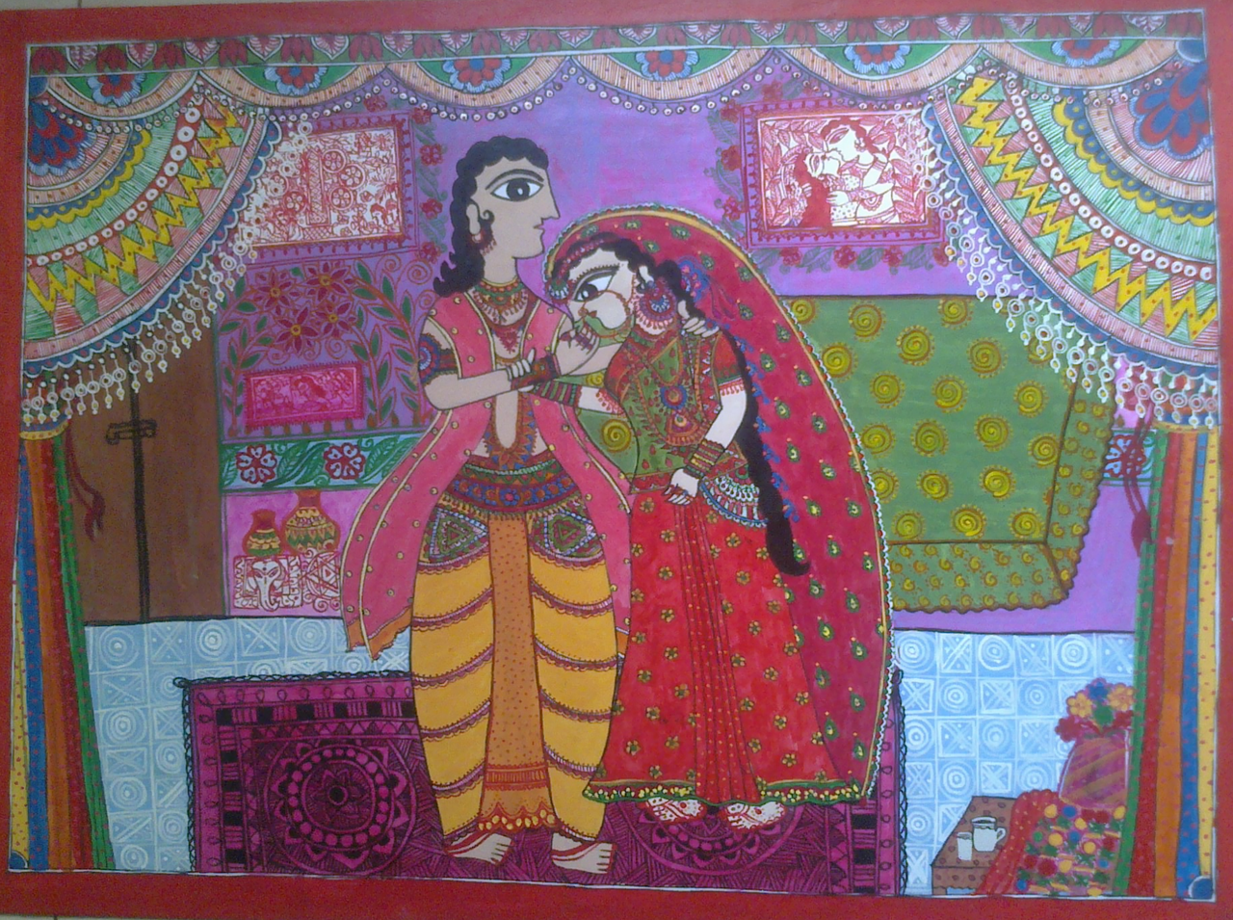

SRC = <https://upload.wikimedia.org/wikipedia/commons/thumb/6/6d/First_night.png/1280px-First_night.png>

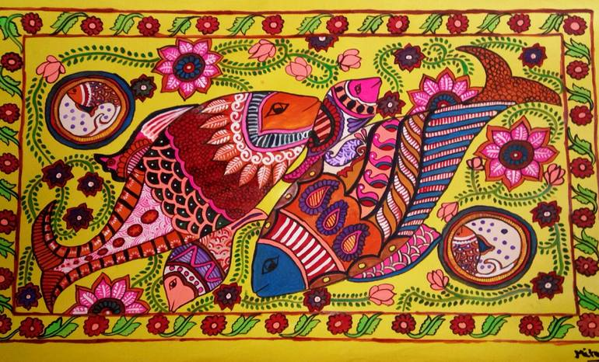

SRC = <https://images.saatchiart.com/saatchi/901011/art/3286707/2356594-SAZWMIEC-32.jpg>

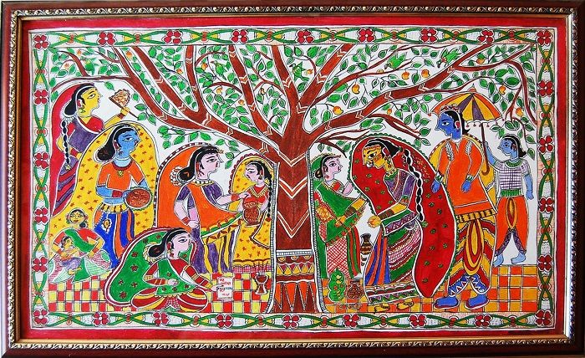

SRC = <https://www.culturalindia.net/iliimages/Madhubani%20painting%205.jpg>

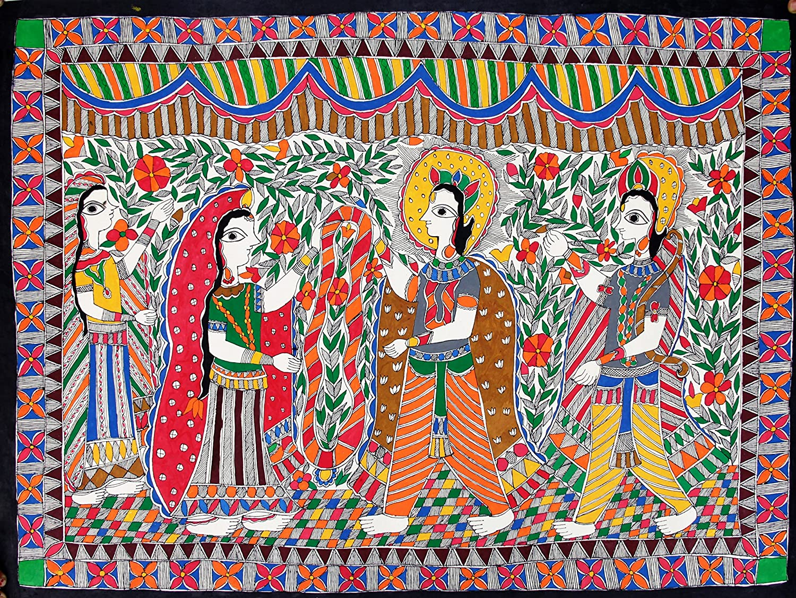

SRC = <https://images-na.ssl-images-amazon.com/images/I/A1zetjUrn0L._SL1500_.jpg>

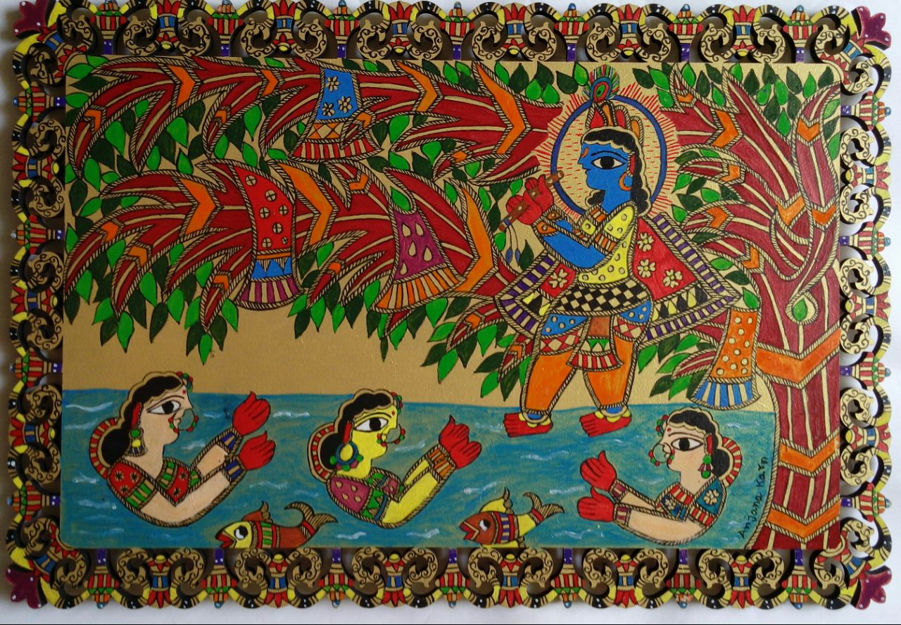

SRC = <https://festivedeal.com/image/data/tasteaura/Painting/Madhubani%20Painting/Madhubani%20Painting%20Depicting%20Krishna%20at%20River%20with%20Gopi.jpg>

# DHOKHRA HANDICRAFT=

The Bastar region, a district in Chhattisgar, is home to tribes who specialise in Dhokra handicraft. It’s wax casting technique has been in India for more than 4,000 years. One of the earliest known dhokra artifacts is the dancing girl of Mohenjo-daro. These products are in great demand in domestic and foreign markets because of primitive simplicity, enchanting folk motifs and forceful form. But, again, very few tribes are practicing the art and no one has been able to come up with a technology to save the 250-year-old legacy.

UPTO HERE - <https://www.indiatimes.com/culture/who-we-are/9-indian-art-forms-that-could-disappear-forever-if-they-re-not-saved-250533.html>

***Dhokra*** (also spelt Dokra) is non–ferrous metal casting using the [lost-wax casting](https://en.wikipedia.org/wiki/Lost-wax_casting) technique. This sort of metal casting has been used in [India](https://en.wikipedia.org/wiki/India) for over 4,000 years and is still used. One of the earliest known lost wax artefacts is the dancing girl of [Mohenjo-daro](https://en.wikipedia.org/wiki/Mohenjo-daro).[[1]](https://en.wikipedia.org/wiki/Dhokra#cite_note-missouri-1) The product of dhokra artisans are in great demand in domestic and foreign markets because of primitive simplicity, enchanting folk motifs and forceful form. Dhokra horses, elephants, peacocks, owls, religious images, measuring bowls, and lamp caskets etc., are highly appreciated.[[2]](https://en.wikipedia.org/wiki/Dhokra#cite_note-2) The lost wax technique for casting of copper based alloys has also been found in [China](https://en.wikipedia.org/wiki/China), [Egypt](https://en.wikipedia.org/wiki/Egypt), [Malaysia](https://en.wikipedia.org/wiki/Malaysia), [Nigeria](https://en.wikipedia.org/wiki/Nigeria), [Central America](https://en.wikipedia.org/wiki/Central_America), and other places.

## The process[[edit](https://en.wikipedia.org/w/index.php?title=Dhokra&action=edit&section=1)]

There are two main processes of lost wax casting: solid casting and hollow casting. While the former is predominant in the [south of India](https://en.wikipedia.org/wiki/South_India) the latter is more common in Central and [Eastern India](https://en.wikipedia.org/wiki/East_India). Solid casting does not use a clay [core](https://en.wikipedia.org/wiki/Core_(manufacturing)) but instead a solid piece of wax to create the mould; hollow casting is the more traditional method and uses the clay core.[[1]](https://en.wikipedia.org/wiki/Dhokra#cite_note-missouri-1)

The first task in the lost wax hollow casting process consists of developing a clay core which is roughly the shape of the final cast image. Next, the clay core is covered by a layer of wax composed of pure [beeswax](https://en.wikipedia.org/wiki/Beeswax), [resin](https://en.wikipedia.org/wiki/Resin) from the tree *Damara orientalis*, and [nut oil](https://en.wikipedia.org/wiki/List_of_vegetable_oils#Nut_oils). The wax is then shaped and carved in all its finer details of design and decorations. It is then covered with layers of clay, which takes the negative form of the wax on the inside, thus becoming a mould for the metal that will be poured inside it. Drain ducts are left for the wax, which melts away when the clay is cooked. The wax is then replaced by the molten metal, often using brass scrap as basic raw material. The liquid metal poured in hardens between the core and the inner surface of the mould. The metal fills the mould and takes the same shape as the wax. The outer layer of clay is then chipped off and the metal icon is polished and finished as desired.[[1]](https://en.wikipedia.org/wiki/Dhokra#cite_note-missouri-1)[[3]](https://en.wikipedia.org/wiki/Dhokra#cite_note-3)

## The name[[edit](https://en.wikipedia.org/w/index.php?title=Dhokra&action=edit&section=2)]

Dhokra Damar tribes are the main traditional [metalsmiths](https://en.wikipedia.org/wiki/Metalsmith) of [West Bengal](https://en.wikipedia.org/wiki/West_Bengal) and [Odisha](https://en.wikipedia.org/wiki/Odisha). Their technique of lost wax casting is named after their tribe, hence Dhokra metal casting. The tribe extends from [Jharkhand](https://en.wikipedia.org/wiki/Jharkhand) to West Bengal and [Orissa](https://en.wikipedia.org/wiki/Odisha); members are distant cousins of the [Chhattisgarh](https://en.wikipedia.org/wiki/Chhattisgarh) Dhokras. A few hundred years ago, the Dhokras of Central and Eastern India traveled south as far as [Kerala](https://en.wikipedia.org/wiki/Kerala) and north as far as [Rajasthan](https://en.wikipedia.org/wiki/Rajasthan) and hence are now found [all over India](https://en.wikipedia.org/wiki/List_of_regions_of_India). Dhokra, or Dokra, craft from [Dwariapur](https://en.wikipedia.org/wiki/Dwariapur,_Bardhaman), West Bengal, is popular. Recently [Adilabad](https://en.wikipedia.org/wiki/Adilabad) [Dokra](https://en.wikipedia.org/w/index.php?title=Dokra&action=edit&redlink=1) from [Telangana](https://en.wikipedia.org/wiki/Telangana) got Geographical Indicator tag in 2018.

UPTO HERE = <https://en.wikipedia.org/wiki/Dhokra>

From the heart of West Bengal comes an art so eternal, it is cast in the absoluteness of metal. An ancient method of making metal artefacts, [Dhokra](http://www.craftsvilla.com/cvfeeds/i-day-dokra-craftsvilla?utm_source=craftsvillablog&utm_medium=post&utm_campaign=dhokra-art-history) art goes back 5000 years. What’s shocking, however, is that this tribal art form, done by the traditional metalsmiths of Bengal – the Dhokra Damar tribes, has survived the test of time and is still in use today. Here’s a look at the journey of this metal art from the heartlands of Bengal to the rest of the world.

**What is Dhokra art?**  
Dhokra art is essentially stunning metal figurines fashioned from bronze and copper based alloys using a ‘lost wax casting’ known as ‘cire perdue’ in French. There are several processes involved in the making of Dhokra art and hence, a single piece could take up to a month or two to be created.

**Decline of Dhokra art**  
It is unfortunate that this beautiful artwork is facing an obvious decline. The steady increase in the cost of raw material makes the end products way too expensive to attract enough buyers. As a result, artisans have been showing less interest in producing such master works. Lack of inspiration, encouragement and knowledge of new designs as well as the inability to adapt to modernization have also contributed to the decline of this artwork.

While there is still a heavy demand for these sculptures both commercially and in international markets, in cities like Milan, Paris and London, the primitive techniques and lack of access to modern technology causes a delay in production

UPTO HERE = <https://www.craftsvilla.com/blog/dhokra-art-metal-casting-technique-from-west-bengal/>

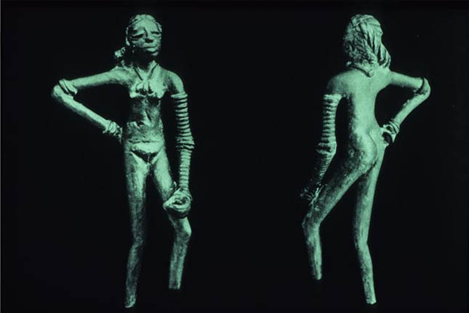

SRC = <http://s3-ap-southeast-1.amazonaws.com/assets1.craftsvilla.com/blog/wp-content/uploads/2016/12/13162405/dhokra_art_dancing_girl.jpg>

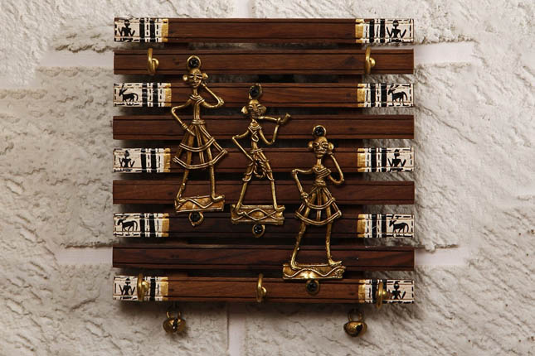

SRC - <http://s3-ap-southeast-1.amazonaws.com/assets1.craftsvilla.com/blog/wp-content/uploads/2016/12/13163322/dhokra_art2.jpg>

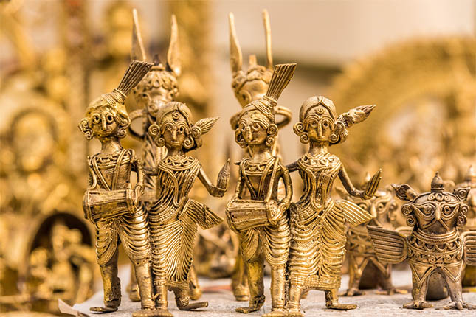

SRC = <https://s3-ap-southeast-1.amazonaws.com/assets1.craftsvilla.com/blog/wp-content/uploads/2016/12/13161125/dhokra_art.jpg>

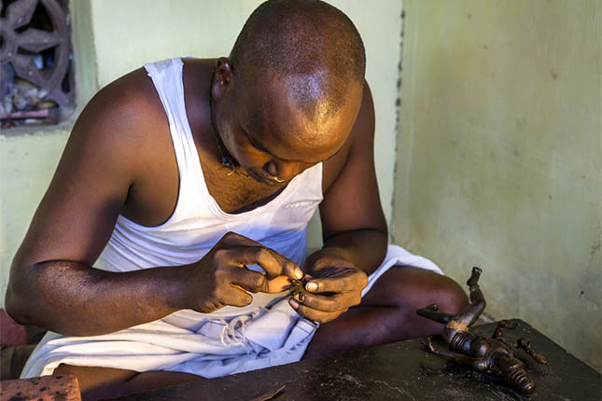

SRC = <http://s3-ap-southeast-1.amazonaws.com/assets1.craftsvilla.com/blog/wp-content/uploads/2016/12/13161126/dhokra_art_artist.jpg>

art forms:_

<https://www.indiatoday.in/education-today/gk-current-affairs/story/indian-art-318128-2016-04-15>